**Name**: Paramprakash Makwana

**Module 4 – Introduction to DBMS**

Lab 1.1: Create a new database named school_db and a table called students with the following columns: student_id, student_name, age, class, and address.

Ans:- CREATE DATABASE school_db

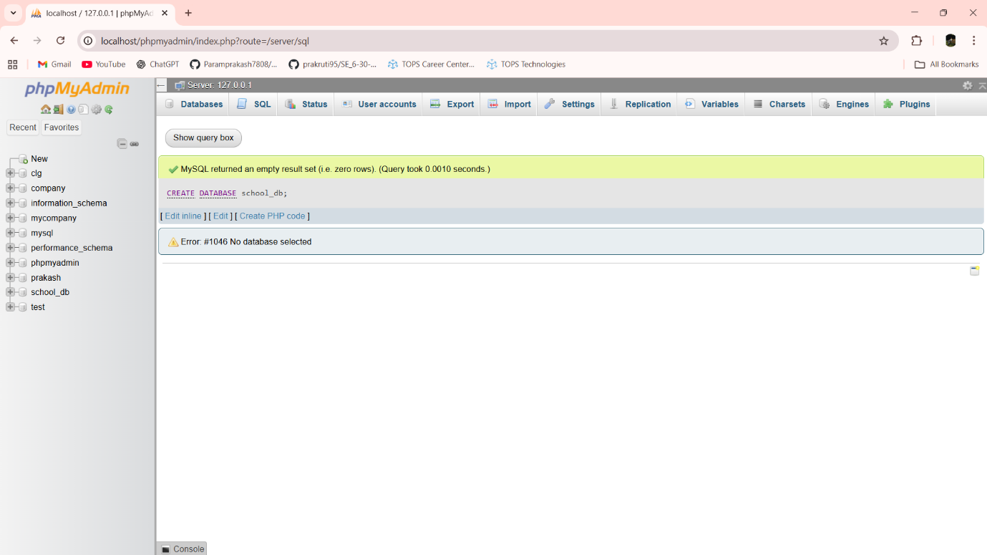

CREATE TABLE students (student_id int PRIMARY KEY AUTO_INCREMENT,student_name varchar(30),age int,class varchar(30),address varchar(50))

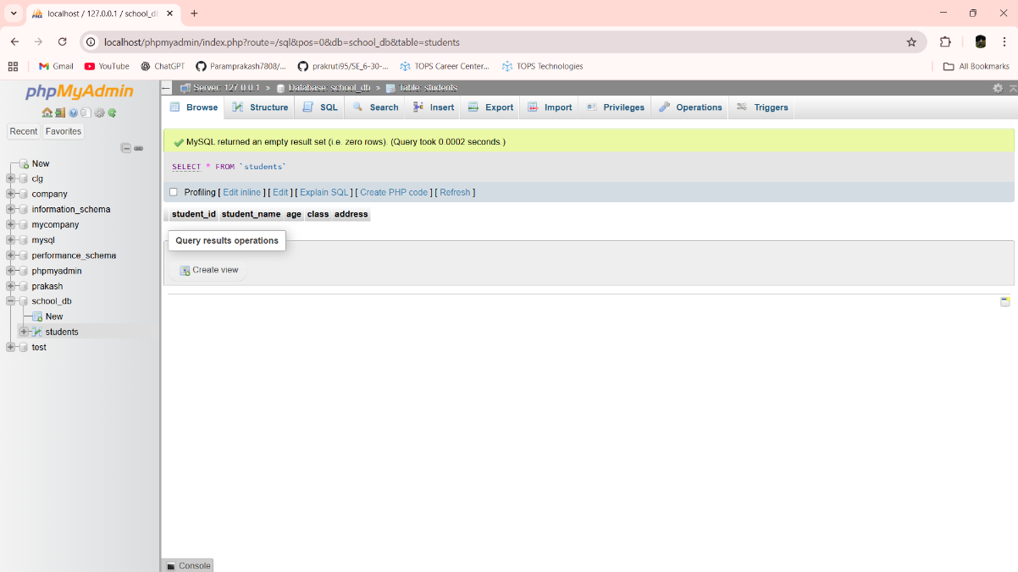

Lab 1.2: Insert five records into the students table and retrieve all records using the SELECT statement.

Ans:- INSERT INTO students (student_id,student_name,age,class,address) VALUES (101,'Prakash',21,'8TD2','Morbi Road Bedi Village Rajkot')

INSERT INTO students (student_id,student_name,age,class,address) VALUES (102,'Sahil',22,'1TD2','Morbi Road Bedi Village Rajkot')

INSERT INTO students (student_id,student_name,age,class,address) VALUES (103,'Ajay',21,'2TD2','Morbi Road Bedi Village Rajkot')

INSERT INTO students (student_id,student_name,age,class,address) VALUES (104,'Nik',22,'3TD2','Morbi Road Bedi Village Rajkot')

INSERT INTO students (student_id,student_name,age,class,address) VALUES (105,'Mayur',20,'4TD2','Morbi Road Bedi Village Rajkot')

SELECT * FROM students

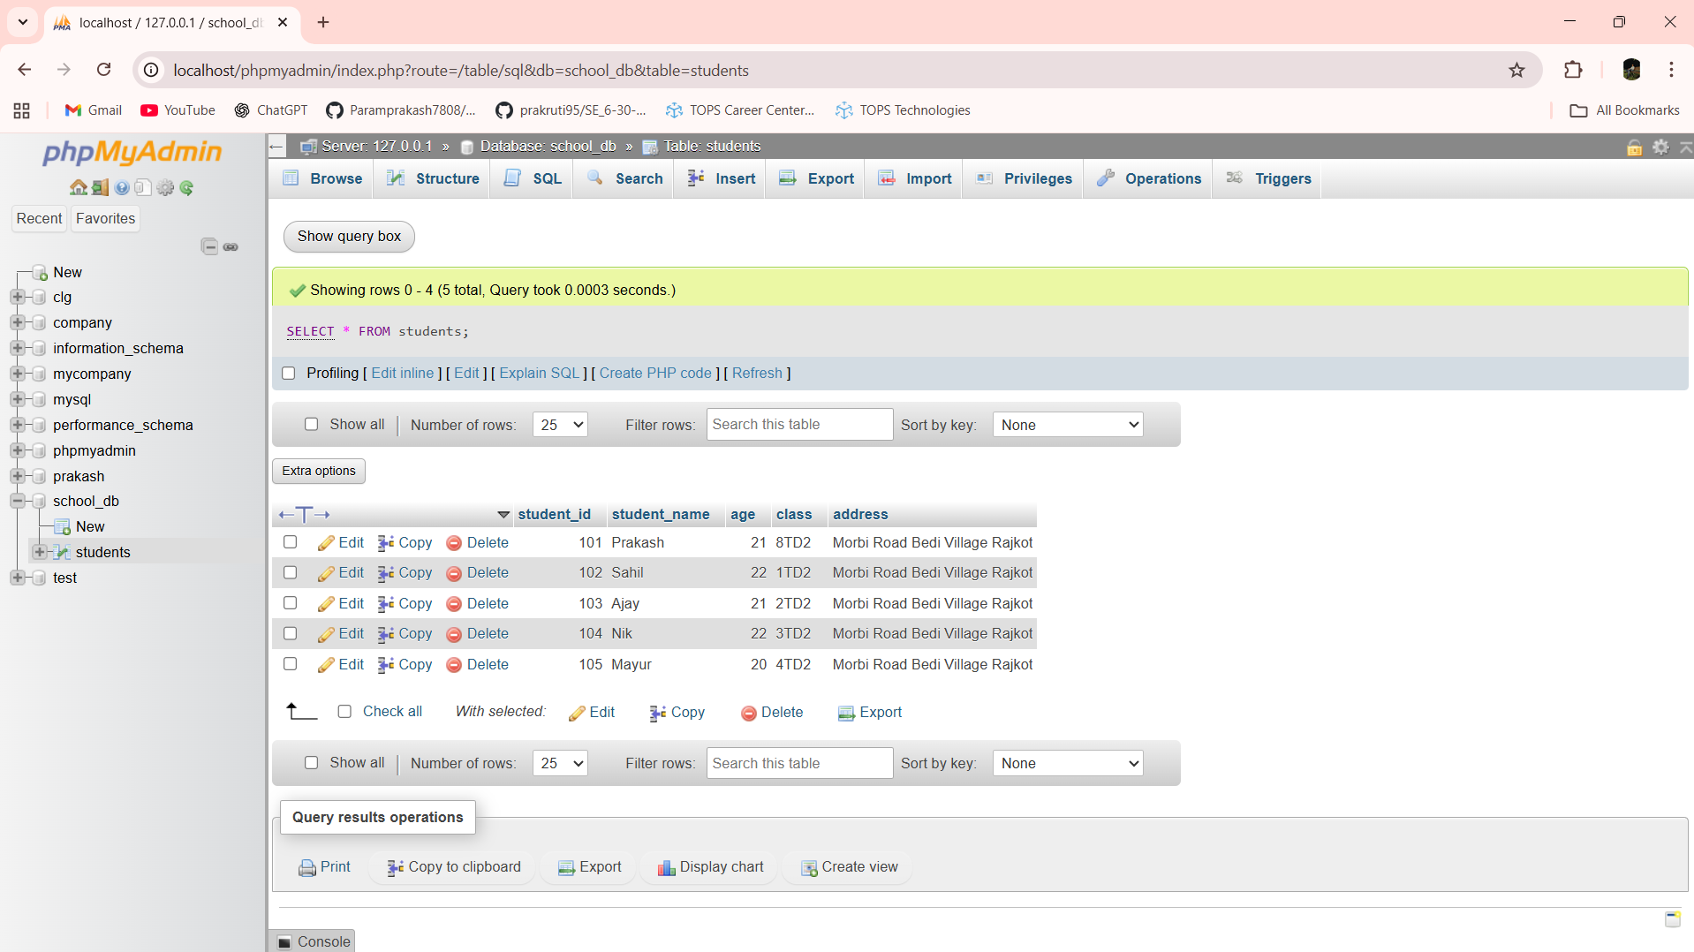

Lab 2.1: Write SQL queries to retrieve specific columns (student_name and age) from the students table.

Ans:- SELECT student_name,age FROM students

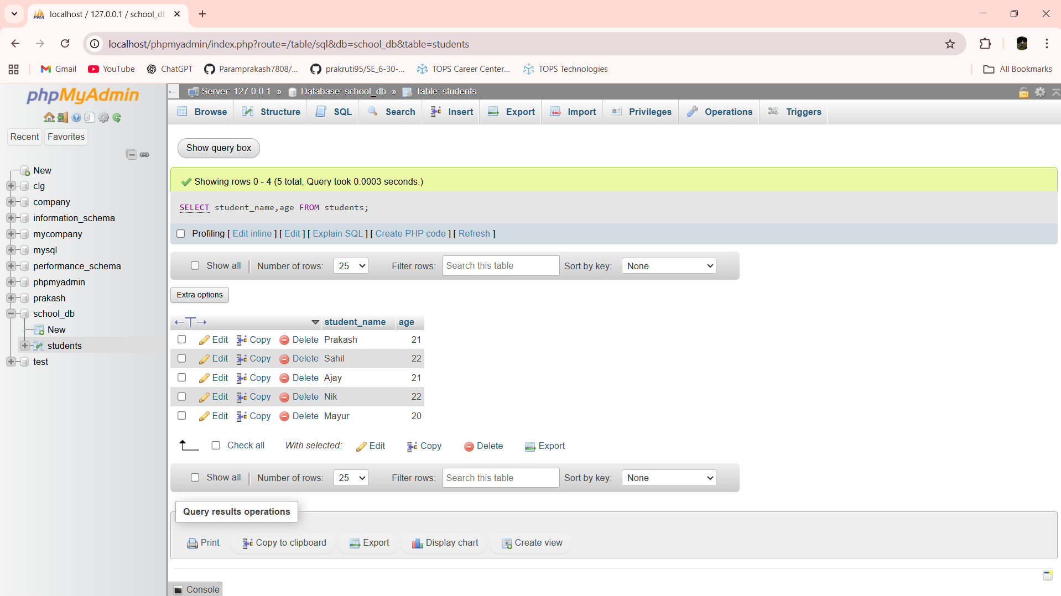

Lab 2.2: Write SQL queries to retrieve all students whose age is greater than 10.

Ans:- SELECT * FROM students WHERE age > 10

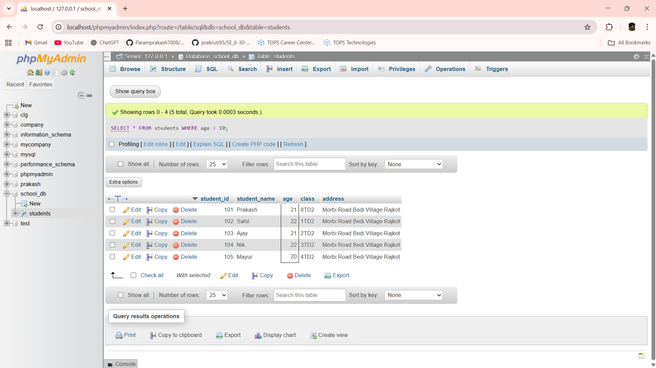

Lab 3.1: Create a table teachers with the following columns: teacher_id (Primary Key), teacher_name (NOT NULL), subject (NOT NULL), and email (UNIQUE).

Ans:- CREATE TABLE teachers(teacher_id int Primary Key AUTO_INCREMENT,teacher_name varchar(30), subject varchar(30),email varchar(30))

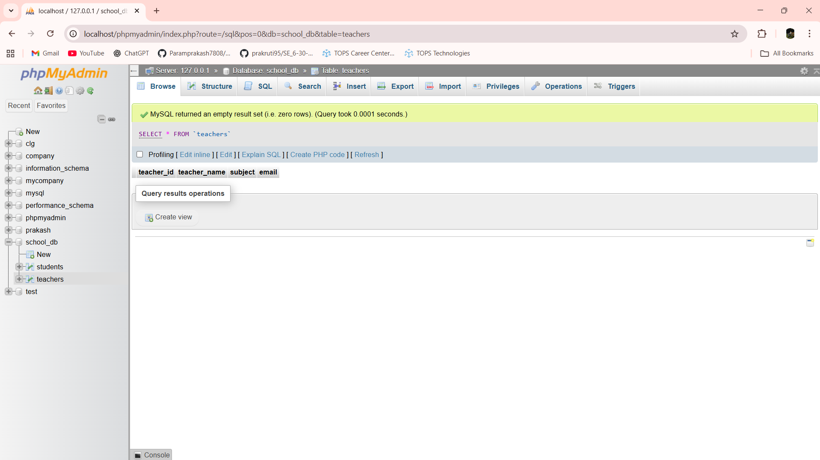

Lab 3.2: Implement a FOREIGN KEY constraint to relate the teacher_id from the teachers table with the students table.

Ans:- ALTER TABLE students ADD CONSTRAINT fk_teacher FOREIGN KEY (teacher_id) REFERENCES teachers(teacher_id)

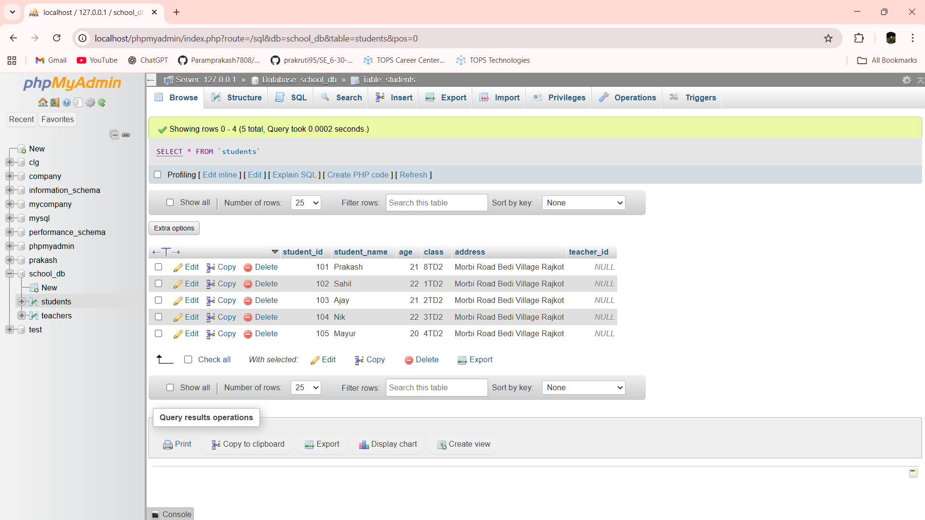

Lab 4.1: Create a table courses with columns: course_id, course_name, and course_credits. Set the course_id as the primary key.

Ans:- CREATE TABLE courses(course_id int PRIMARY KEY AUTO_INCREMENT,course_name varchar(30),course_credits int)

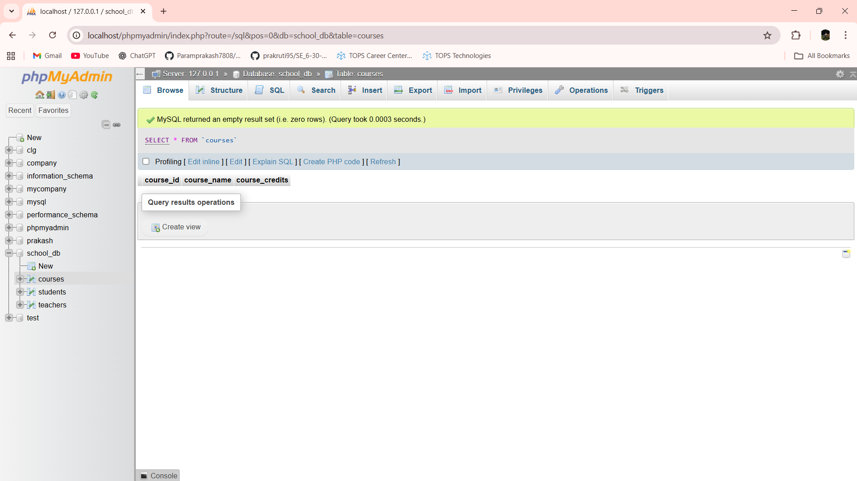

Lab 4.2: Use the CREATE command to create a database university_db.

Ans:- CREATE DATABASE university_db

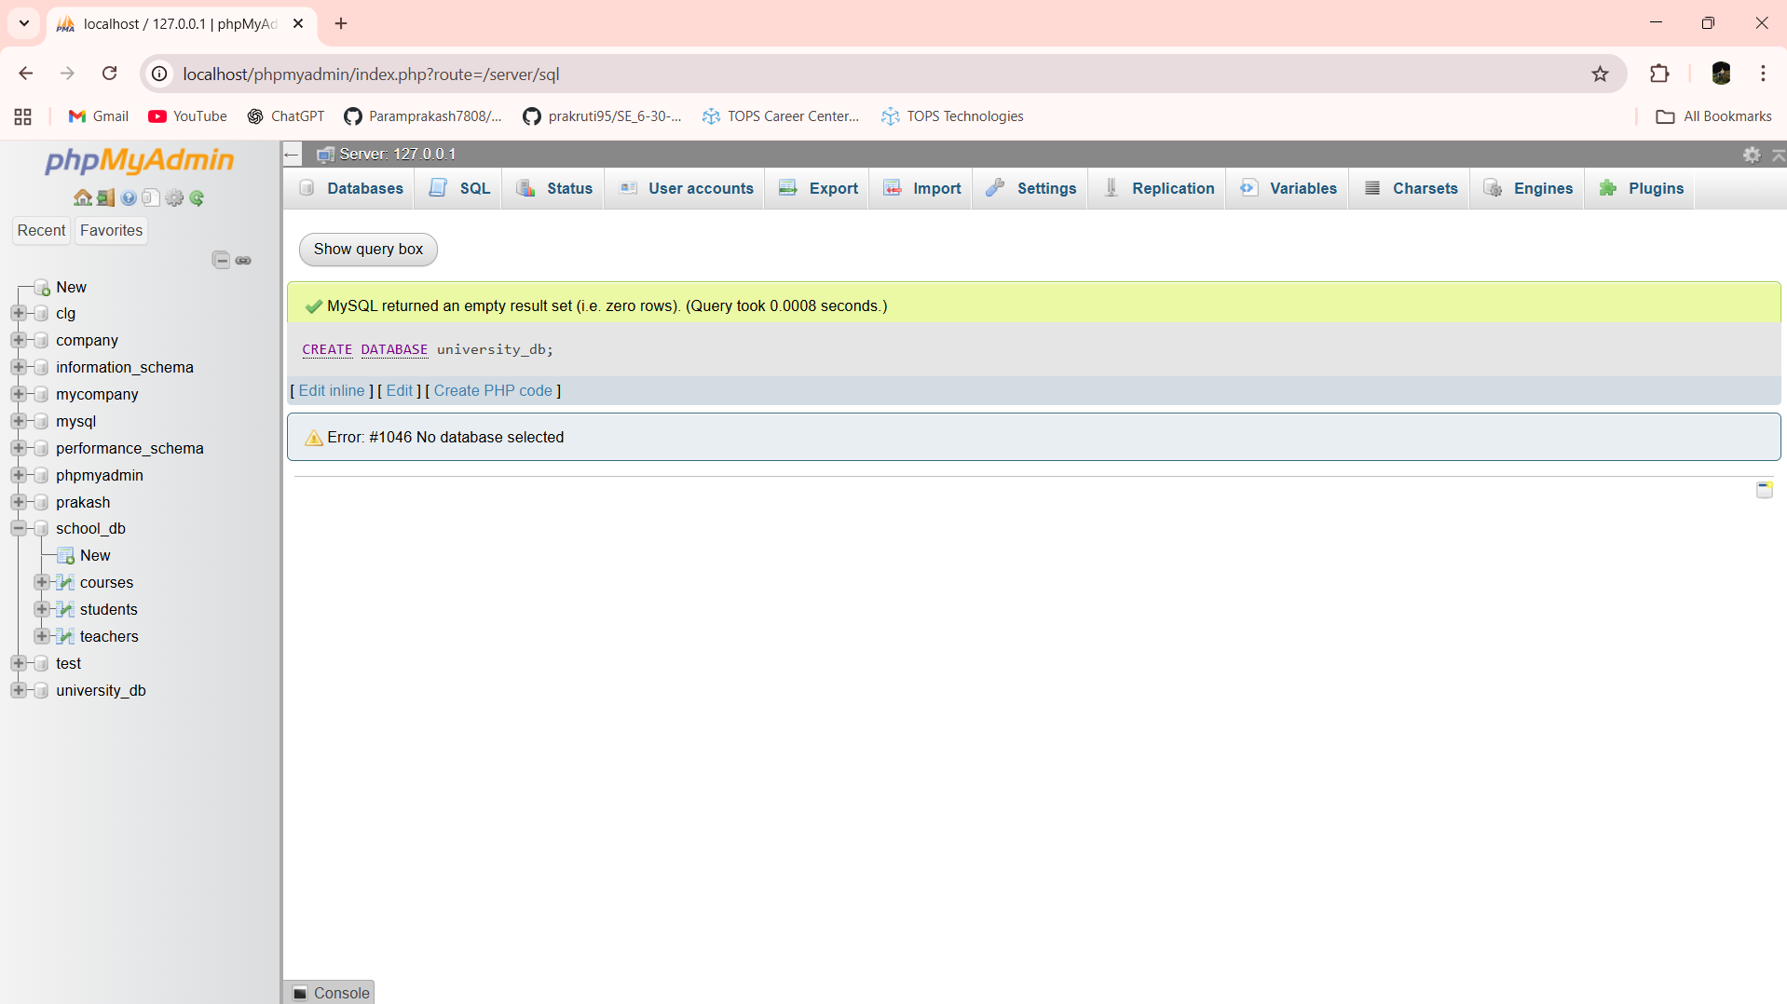

Lab 5.1: Modify the courses table by adding a column course_duration using the ALTER command.

Ans:- ALTER TABLE courses ADD course_duration varchar(30)

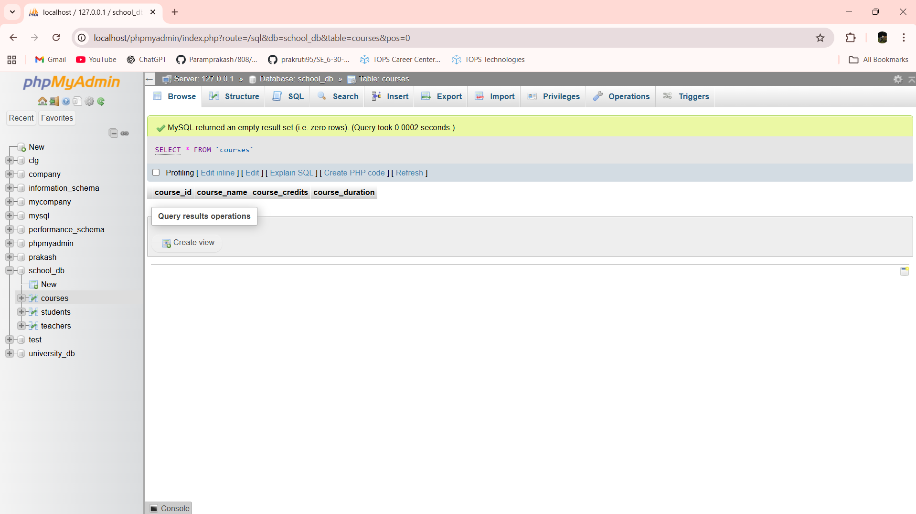

Lab 5.2: Drop the course_credits column from the courses table.

Ans:- ALTER TABLE courses DROP COLUMN course_credits

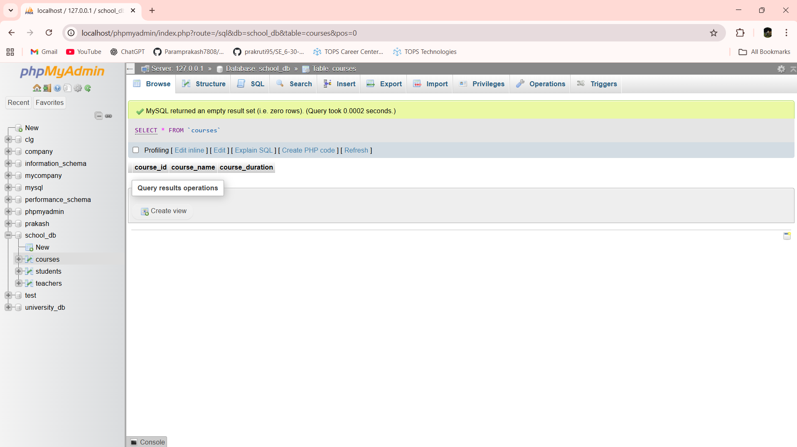

Lab 6.1: Drop the teachers table from the school_db database.

Ans:- DROP TABLE teachers

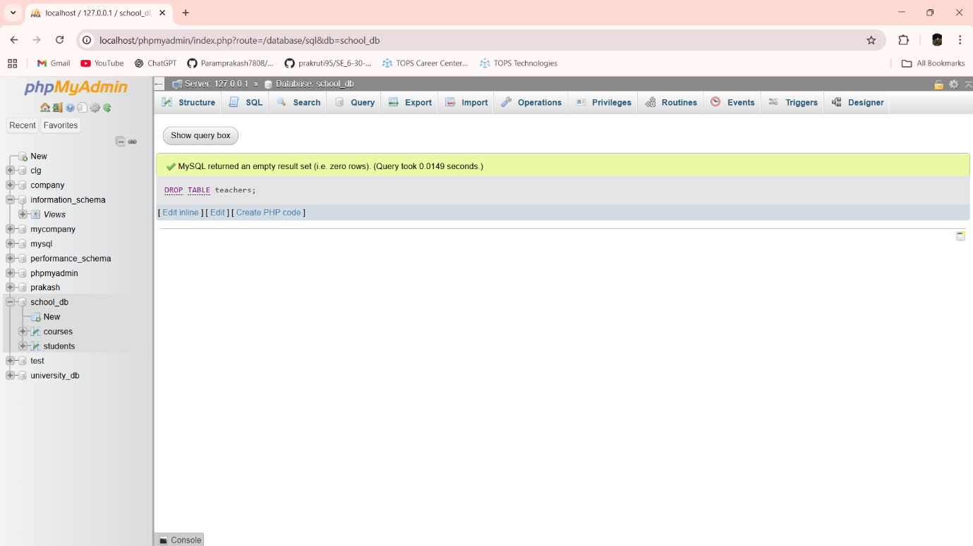

Lab 6.2: Drop the students table from the school_db database and verify that the table has been removed.

Ans:- DROP TABLE students

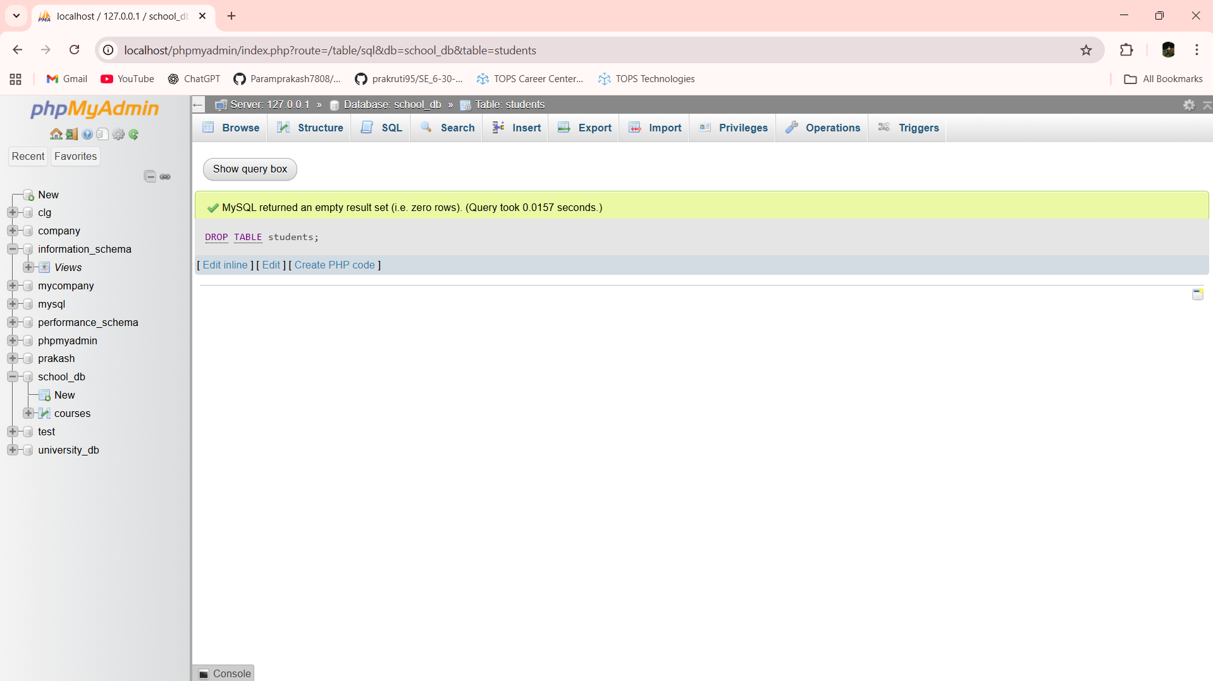

Lab 7.1: Insert three records into the courses table using the INSERT command.

Ans:- INSERT INTO courses (course_id,course_name,course_duration) VALUES (101,'Python','6 Months')

INSERT INTO courses (course_id,course_name,course_duration) VALUES (102,'Flutter','6 Months')

INSERT INTO courses (course_id,course_name,course_duration) VALUES (103,'Java','6 Months')

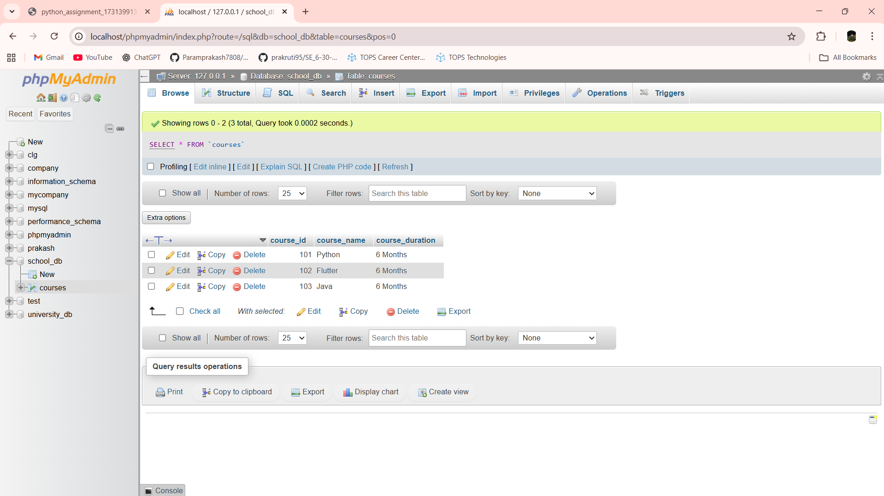

Lab 7.2: Update the course duration of a specific course using the UPDATE command.

Ans:- UPDATE courses SET course_duration = '7 Months' WHERE course_id = 103

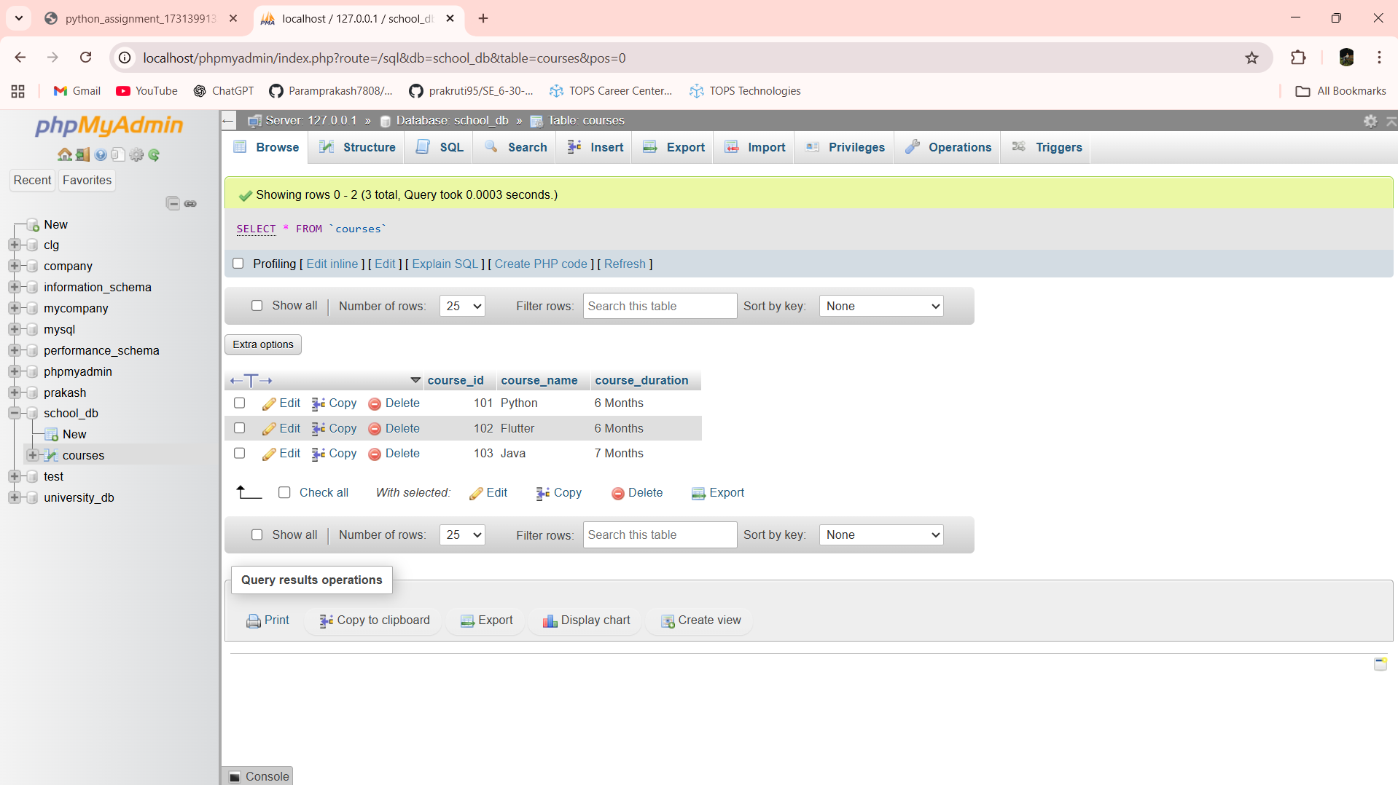

Lab 7.3: Delete a course with a specific course_id from the courses table using the DELETE command.

Ans:- DELETE FROM courses WHERE course_id = 103

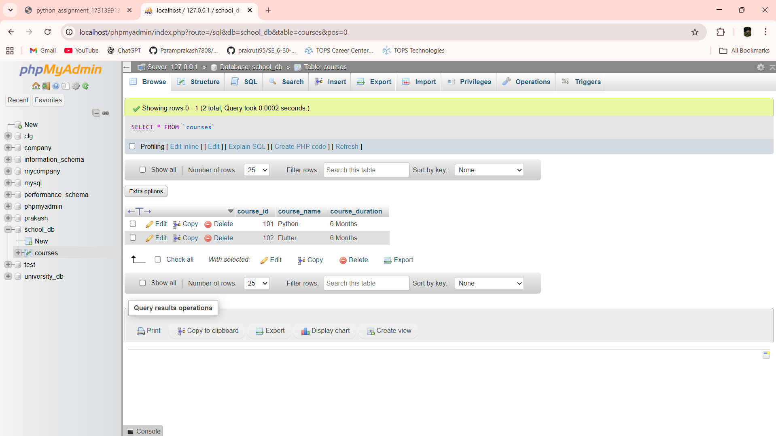

Lab 8.1: Retrieve all courses from the courses table using the SELECT statement.

Ans:- SELECT * FROM courses

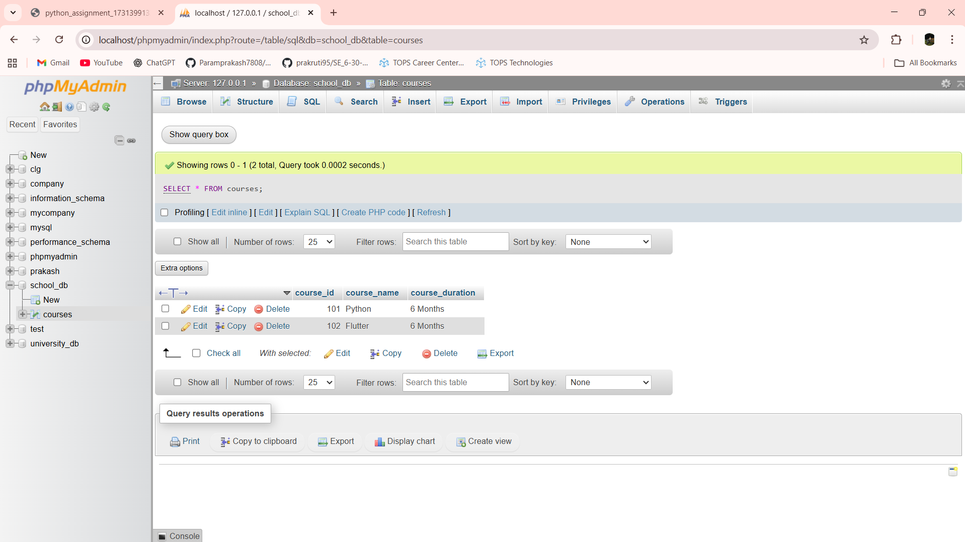

Lab 8.2: Sort the courses based on course_duration in descending order using ORDER BY.

Ans:- SELECT * FROM courses ORDER BY course_duration DESC

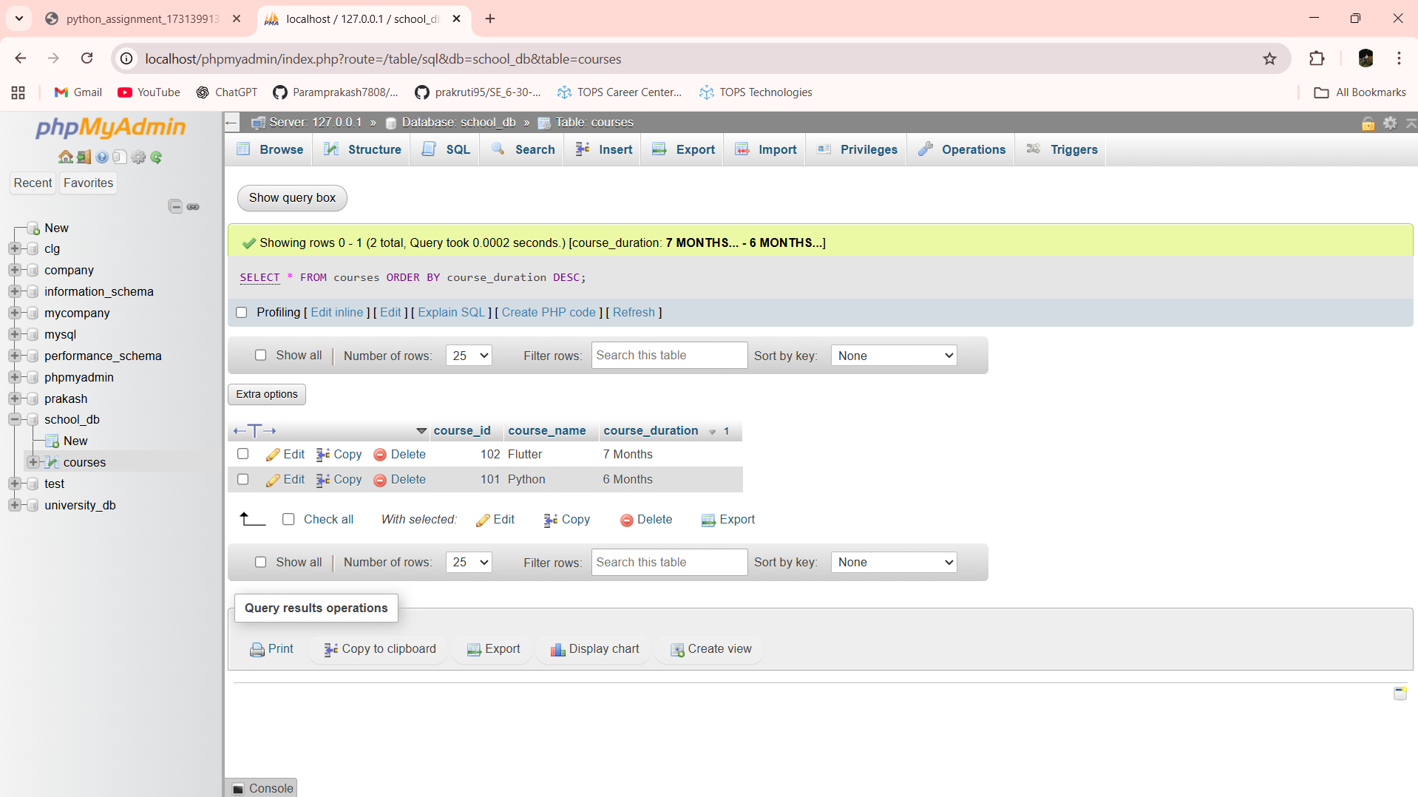

Lab 8.3: Limit the results of the SELECT query to show only the top two courses using LIMIT.

Ans:- SELECT * FROM courses LIMIT 2

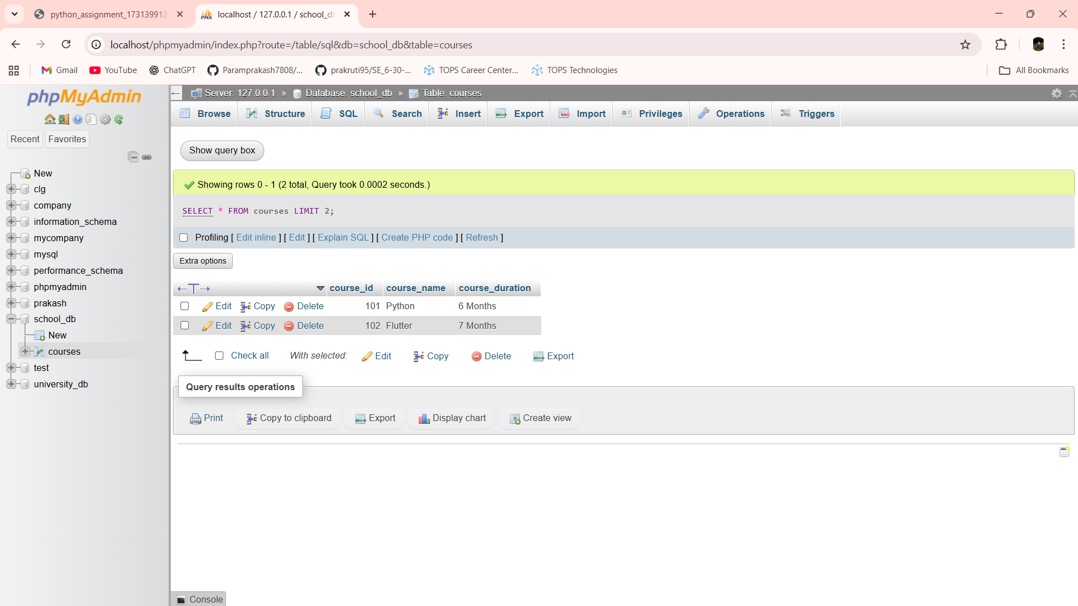

Lab 9.1: Create two new users user1 and user2 and grant user1 permission to SELECT from the courses table.

Ans:-